Assignment 4

Code
Screenshot:

1.1 Write a Python Program (with class concepts) to find the area of the triangle using the below
formula.
area = (s*(s-a)*(s-b)*(s-c)) ** 0.5
Function to take the length of the sides of triangle from user should be defined in the parent
class and function to calculate the area should be defined in subclass.
Code
#Area of a Triangle
class Triangle():
def __init__(self,a,b,c):
self.a = a
self.b = b
self.c = c

def calculate_area(self):
a = self.a
b = self.b
c = self.c
# calculate the semi-perimeter
s = (self.a + self.b + self.c) / 2
return (s*(s-self.a)*(s-self.b)*(s-self.c)) ** 0.5
tri = Triangle(3,4,5)
print("Area of Triangle:",tri.calculate_area())
Screenshot:
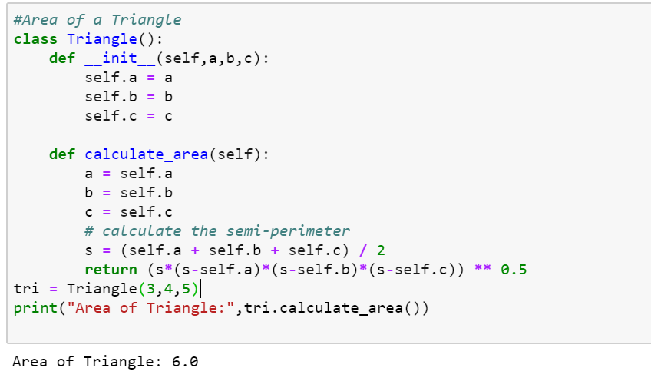
1.2 Write a function filter_long_words() that takes a list of words and an integer n and returns
the list of words that are longer than n.
Code
#Write a function filter_long_words() that takes a list of words and an integer n and returns
# the list of words that are longer than n.

def filterlongword(string,number):
return [word for word in string if len(word) > number]

def main():
word = input("Please input the list of words: ")
words= word.split(',')
integer = eval(input("Please input an integer: "))
words1 = filterlongword(words,integer)
print("The list of words greater than the integer is",words1)
main()
Screenshot:
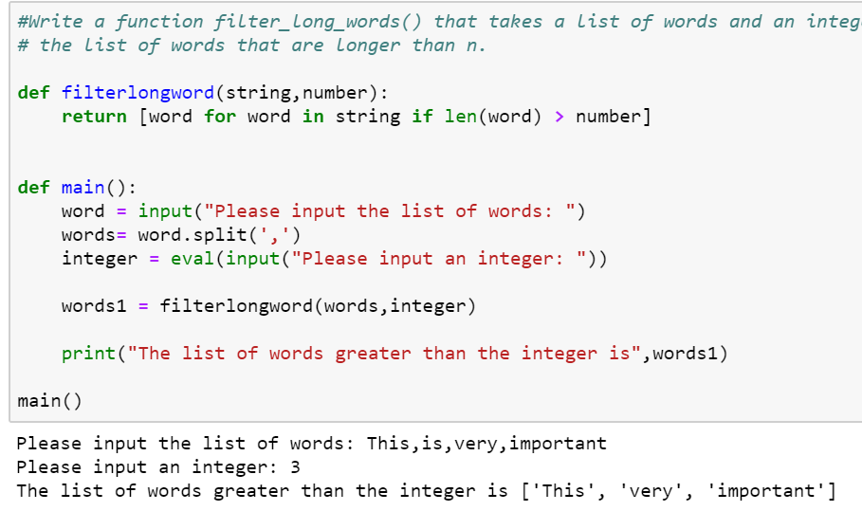

2.1 Write a Python program using function concept that maps list of words into a list of integers
representing the lengths of the corresponding words.
Hint: ​If a list [ ab,cde,erty] is passed on to the python function output should come as [2,3,4]
Here 2,3 and 4 are the lengths of the words in the list.
Code
def map_to_lengths_for(words):
lengths = []
for word in words:
lengths.append(len(word))
return lengths

def map_to_lengths_map(words):
return map(len, words)

def map_to_lengths_lists(words):
return [len(word) for word in words]

if __name__ == "__main__":
words = ['this', 'is so', 'impossible']
print (map_to_lengths_for(words))
#print (map_to_lengths_map(words))
print (map_to_lengths_lists(words))
Screenshot:
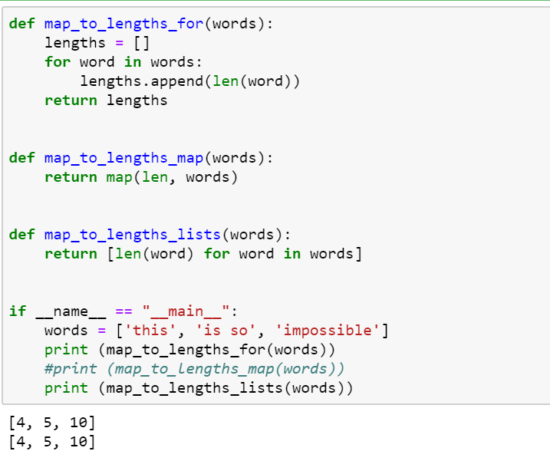

2.2 Write a Python function which takes a character (i.e. a string of length 1) and returns True if
it is a vowel, False otherwise.
Code
def checkvowel(v):
if(v=='a' or v=='e' or v=='i' or v=='o' or v=='u'):
return True
else:
return False

#v='a'
v=input("Enter the string to check:")
checkvowel(v)

if checkvowel(v) == True:
print("The entered character is Vowel")
else:
print("The entered character is not Vowel")
Screenshot:
